An Empirical Investigation of the Impact of Monetary Policy on the Economic Activity of Wyoming State

Ryan Minghao Zhao

**Introduction**

For many years Economic Researchers have been interested in examining if monetary policies have a causal effect on economic activity and if the effect existed, how it would be measured. Macroeconomists have proposed the Philips’ curve which illustrated the relationship between inflation and short-run output according to the following equation: $π_{t}= E_{t-1}\left[π_{t}\right]+vY_{t}+ ξ_{t}$ ()When inflation rate ($π_{t}$) increases, short-run output also increases ($Y_{t}$). The shift in short-run output might also impact other indicators of economic activity as well, such as the unemployment rate. Furthermore, by the Fisher Equation: $R_{t}=i_{t}- π_{t}\overset{⇒}{} π_{t}= i_{t}+ R_{t}$ inflation is also closely correlated with the short-term interest rate i.e. The Federal Funds Rate (FFR). In theory, all the parameters that measure economic activity, the FFR, inflation, growth rate of real GDP and unemployment rate are closely related with one another, as a shift in one of the levels might lead to changes in the rest. However, it is uncertain whether the above relationships are causal or a correlation, and policy makers were eager to look for variables that could potentially “cause” a stimulation in economic activity so that they can draft policies accordingly. **This research project was aimed to investigate the causal effect of monetary policies on the growth rate of real GDP, and unemployment rate**.

This project utilized Vector Autoregression as the primary too for analyzing time-series data of Wyoming state, and by plotting the impulse response function diagrams of various variables, we were able to deduce whether the causal relationship between FFR and growth rate/ unemployment existed. If so, how strong was the relationship?

This paper contains the following sections: Firstly, we described the major challenges of of getting a causal estimate, and the necessary approach taken to overcome them. Secondly, empirical evidence on the presence of causal effects and a rough mathematical framework on the theory behind vector autoregression was presented as well as necessary figures. And lastly, some hidden caveats that might hinder the validity of the results were also discussed in detail.

**Monetary Policy Effectiveness: Empirical Challenges**

Studying the causal effect of the Federal Funds rate (FFR) on real GDP growth rate and unemployment rate can be a challenging process, simply using the Ordinary Least Squares (OLS) approach to regress GDP growth rate against FFR would not produce a consistent causal estimate, due to the problem of endogeneity. This problem occurs when there is a simultaneous relationship between the two variables, depicted in the equations below:

$$Y_{t}^{growth}= α+ β×{FFR}_{t}+u_{it}$$

$${FFR}_{t}= δ+ γ×Y_{t}^{growth}+ϵ_{it}$$

Although, there might exist a possible causal relationship between FFR and real GDP growth rate ($Y_{t}^{growth}$), conversely, changes in FFR levels could also result from the changes in $Y_{t}^{growth}$. For instance, suppose policymakers observed there was a negative value in $Y_{t}^{growth}$ in Wyoming this quarter, they might consider raising the FFR today in order to alleviate the recession and stimulate output growth for the next quarter. This problem was known as endogeneity bias and resulted in the explanatory variable ( $Y_{t}^{growth}$) being correlated with the error term, which produced an inconsistent slope coefficient $β$. The same problem could potentially occur for Wyoming’s unemployment rate. Therefore, it is essential to take this problem into consideration when performing the regression analysis for this project.

This project used Vector Autoregression (VAR) as the main approach to eliminate endogeneity. We showed the relationship of Federal Funds Rate and real GDP growth in vector notation to acknowledge endogeneity. Denote the reduced and structural of the vector autoregression process as the equations below:

Structural form

Reduced form

$$\left[\begin{matrix}Y_{t}^{growth} \\ {FFR}_{t}\end{matrix}\right]= \left[\begin{matrix}μ_{1} \\ μ_{2}\end{matrix}\right]+ \left[\begin{matrix}A_{11} & A_{12} \\ A_{21} & A_{22}\end{matrix}\right]\left[\begin{matrix}Y_{t-1}^{growth} \\ {FFR}_{t-1}\end{matrix}\right]+\left[\begin{matrix}A_{11}^{*} & A_{12}^{*} \\ A_{21}^{*} & A_{22}^{*}\end{matrix}\right]\left[\begin{matrix}Y_{t-2}^{growth} \\ {FFR}_{t-2}\end{matrix}\right]+ \left[\begin{matrix}e_{1t} \\ e_{2t}\end{matrix}\right]$$

$$\left[\begin{matrix}Y_{t}^{growth} \\ {FFR}_{t}\end{matrix}\right]= \left[\begin{matrix}0 & α_{FFR} \\ α_{y} & 0\end{matrix}\right]\left[\begin{matrix}Y_{t}^{growth} \\ {FFR}_{t}\end{matrix}\right]+ \left[\begin{matrix}a_{11} & a_{12} \\ a_{21} & a_{22}\end{matrix}\right]\left[\begin{matrix}Y_{t-1}^{growth} \\ {FFR}_{t-1}\end{matrix}\right]+\left[\begin{matrix}a_{11}^{*} & a_{12}^{*} \\ a_{21}^{*} & a_{22}^{*}\end{matrix}\right]\left[\begin{matrix}Y_{t-2}^{growth} \\ {FFR}_{t-2}\end{matrix}\right]+ \left[\begin{matrix}ε_{t}^{y} \\ ε_{t}^{FFR}\end{matrix}\right]$$

In VAR, both equations were estimated simultaneously, therefore the endogeneity problem was resolved. Starting from estimating the reduced form of the VAR process, we were able to recover the $α$ and $a_{ij}$ parameters in the structural form. According to the solution proposed by Sims in 1980 we have to assume one of the $α$ parameters to equal to zero for the estimation to work. Hence, by setting the coefficient for FFR ($α_{FFR}$) to be zero we argue that the FFR did not have a contemporaneous effect on $Y_{t}^{growth}$. In other words, it was proposed that the effects of a change in FFR levels on $Y_{t}^{growth}$ would be delayed by at least one lag. The change would not impact $Y_{t}^{growth}$ in the same quarter but it might still cause changes in $Y_{t}^{growth}$ for upcoming quarters ahead. To a large extent, this assumption would still be valid because a change in monetary policy today would less likely impact the GDP growth of the same quarter, as it takes a few months for companies and citizens to respond to this change in short-term interest rate and adjust their investment and consumption patterns accordingly. Setting the coefficient $α_{FFR}=0$ would allow us to estimate the other parameters and determine whether a temporary shock in FFRt () can cause a change in the growth rate. In this case, a shock in FFR ($ε_{t}^{FFR}$) was used as an instrument to measure the causal effect of FFR on GDP growth rate, assuming that $ε_{t}^{FFR}$ was uncorrelated with $ε_{t}^{y}$. Therefore, using the properties of time-series data and the instrumental variables method it is possible to solve the endogeneity problem.

A similar vector autoregression approach was adopted with the unemployment rate of Wyoming, and the following reduced and structural form was obtained:

Structural form

Reduced form

$$\left[\begin{matrix}U_{t} \\ {FFR}_{t}\end{matrix}\right]= \left[\begin{matrix}δ_{1} \\ δ_{2}\end{matrix}\right]+ \left[\begin{matrix}B_{11} & B_{12} \\ B_{21} & B_{22}\end{matrix}\right]\left[\begin{matrix}U_{t-1} \\ {FFR}_{t-1}\end{matrix}\right]+ \left[\begin{matrix}B_{11}^{*} & B_{12}^{*} \\ B_{21}^{*} & B_{22}^{*}\end{matrix}\right]\left[\begin{matrix}U_{t-2} \\ {FFR}_{t-2}\end{matrix}\right]+\left[\begin{matrix}e_{1t}^{'} \\ e_{2t}^{'}\end{matrix}\right]$$

$$\left[\begin{matrix}U_{t} \\ {FFR}_{t}\end{matrix}\right]= \left[\begin{matrix}0 & {α'}_{FFR} \\ α_{u} & 0\end{matrix}\right]\left[\begin{matrix}U_{t} \\ {FFR}_{t}\end{matrix}\right]+ \left[\begin{matrix}b_{11} & b_{12} \\ b_{21} & b_{22}\end{matrix}\right]\left[\begin{matrix}U_{t-1} \\ {FFR}_{t-1}\end{matrix}\right]+\left[\begin{matrix}b_{11}^{*} & b_{12}^{*} \\ b_{21}^{*} & b_{22}^{*}\end{matrix}\right]\left[\begin{matrix}U_{t-2} \\ {FFR}_{t-2}\end{matrix}\right]+ \left[\begin{matrix}ε_{t}^{u} \\ ε_{t}^{FFR}\end{matrix}\right]$$

Similar to the first case, the problem of endogeneity bias still occurs with the unemployment rate data, since FFR can cause changes in short-run output, and affects the unemployment rate as well, but policymakers would also adjust monetary policy after observing changes in the unemployment rate. In order to determine the structural form from the reduced form, and following the Sims’ solution, this time $α_{u}$ was assumed to be zero so the effect of changes to unemployment rate on the FFR is delayed by at least one lag, so the contemporaneous effect can be negligible. This would still be a valid assumption because it is unlikely that the Federal Reserve (Fed) would change the short-term interest rate due to the unemployment rate of only Wyoming state. The Fed would observe the economic activities of all the states and change the FFR accordingly, and since each state’s unemployment can change at different rates, the sole impact of Wyoming’s unemployment rate on FFR would be delayed by at least one quarter. After justifying the assumption $α_{u}=0$ is valid, we would be able to determine the structural form of the VAR process and compute the impulse response functions which measures the potential causal effect of FFR on unemployment rate and real GDP growth rate.

**Data and VAR Model Estimation**

The data used for this project were downloaded from the FRED, we used quarterly data for all the economic indicator variables from the state of Wyoming as our primary database, and computed the quarterly growth rate from the raw GDP data. Some basic analyses were also performed such as plotting the autocorrelation functions (ACF), partial autocorrelation functions (PACF) as well as using the Augmented Dicky Fuller Test to check stationarity of the trends. From the ACF and PACF plots located in the Appendix (p. 11), we deduced that the process of FFR and unemployment rate potentially contain an autoregressive component with order 1 and they were found to be non-stationary data that might contain a stochastic/ deterministic trend.

Before performing vector autoregression (VAR), we used the VARselect function in R to deduce the best order for the regression based on the values of the AIC and BIC computed. For unemployment rate and FFR, a VAR with degree two was performed. We obtained the equation estimates for Federal Funds Rate (FFR) as the dependent variable in the Table 1.

Table 1

Estimation results for equation ffrate:

ffrate = ffrate.l1 + u.l1 + ffrate.l2 + u.l2 + const……………………(1)

Estimate Std. Error t value Pr(>|t|)

ffrate.l1 1.71164 0.08112 21.101 < 2e-16 ***

u.l1 0.05724 0.08490 0.674 0.502

ffrate.l2 -0.75501 0.07985 -9.455 2.2e-15 ***

u.l2 -0.06957 0.08446 -0.824 0.412

const 0.14795 0.17954 0.824 0.412

Residual standard error: 0.3269 on 96 degrees of freedom

Multiple R-Squared: 0.9757, Adjusted R-squared: 0.9747

F-statistic: 964 on 4 and 96 DF, p-value: < 2.2e-16

The coefficients on FFRt-1 and FFRt-2 were found to be statistically significant at the 95% confidence interval, FFRt-1 and FFRt-2 has a positive and negative relationship with current FFR respectively. While the effect of the lags of unemployment rate on FFR was negligible since they are not statistically different from 0 at the 95% confidence interval.

In addition to the FFR equation, the same analysis was performed for the unemployment rate as the dependent variable, the coefficients were shown in Table 2

Table 2

Estimation results for equation u:

u = ffrate.l1 + u.l1 + ffrate.l2 + u.l2 + const……………………..….(2)

Estimate Std. Error t value Pr(>|t|)

ffrate.l1 -0.14465 0.09059 -1.597 0.11361

u.l1 1.29615 0.09481 13.671 < 2e-16 ***

ffrate.l2 0.11855 0.08918 1.329 0.18688

u.l2 -0.42001 0.09433 -4.453 2.29e-05 ***

const 0.59279 0.20050 2.956 0.00392 **

Residual standard error: 0.3651 on 96 degrees of freedom

Multiple R-Squared: 0.8959, Adjusted R-squared: 0.8915

F-statistic: 206.5 on 4 and 96 DF, p-value: < 2.2e-16

This time, the coefficients of the lags of unemployment were found to be statistically significant, Ut-1 and Ut-2 has a positive and negative relationship with current unemployment rate respectively. While the coefficient estimates for FFRt-1 and FFRt-2 were not statistically different from zero.

The covariance matrix of unemployment rate and FFR residuals was also computed in order to deduce the contemporaneous correlation between the two variables. We concluded that there is a negative contemporaneous relationship between the 2 variables, i.e. when there is a positive innovation on FFR, unemployment rate would decrease contemporaneously.

Covariance matrix

|  |  |  |
| --- | --- | --- |
|  | Federal Funds Rate (FFR) | Unemployment rate |
| Federal Funds Rate (FFR) | 0.10689 | -0.02924 |
| Unemployment rate | -0.02924 | 0.13331 |

|  |  |  |
| --- | --- | --- |
|  | Federal Funds Rate (FFR) | Growth rate |
| Federal Funds Rate (FFR) | 0.1068 | 0.2049 |
| Growth rate | 0.2049 | 73.9926 |

The same type of VAR was repeated on the analysis growth rate of real GDP and FFR, and the positive covariance of FFR and growth rate implied that there was a positive contemporaneous relationship between growth rate and FFR, i.e. a positive innovation on the FFR will increase the growth rate of real GDP. In comparison with the unemployment rate, growth rate is more correlated with the FFR.

Covariance matrix

Table 3

ffrate = ffrate.l1 + growth.l1 + ffrate.l2 + growth.l2 + const

Estimate Std. Error t value Pr(>|t|)

ffrate.l1 1.698859 0.077176 22.013 < 2e-16 ***

growth.l1 -0.002273 0.003872 -0.587 0.5586

ffrate.l2 -0.740557 0.075938 -9.752 5.07e-16 ***

growth.l2 0.002759 0.003871 0.713 0.4777

const 0.087615 0.045600 1.921 0.0577

Residual standard error: 0.3268 on 96 degrees of freedom

Multiple R-Squared: 0.9757, Adjusted R-squared: 0.9747

F-statistic: 964.7 on 4 and 96 DF, p-value: < 2.2e-16

Next, we computed the VAR estimates in Table 3, that showcased the relationship of growth rate and FFR and the estimation results for the equation with FFR as the dependent variable was denoted as the following with statistically significant FFR coefficients and negligible growth rate coefficients.

In terms of the estimation results for the equation with growth rate as the dependent variable, one interesting finding was that there were no statistically significant coefficients for the 95% confidence interval when regressing growth rate against FFR and other lags. According to Table 4, both coefficients of the growth rate lags and FFR lags have very large p-values, so we failed to reject the null hypothesis that each coefficient was statistically different from zero, hence a change in the lag of FFR and real GDP growth rate has zero effect on the current GDP growth rate. This finding was considered unique since unlike the other regressions done, this was the only one that did not contain statistically significant coefficients.

Table 4:

growth = ffrate.l1 + growth.l1 + ffrate.l2 + growth.l2 + const

Estimate Std. Error t value Pr(>|t|)

ffrate.l1 3.27647 2.03126 1.613 0.110

growth.l1 0.08368 0.10192 0.821 0.414

ffrate.l2 -2.00042 1.99867 -1.001 0.319

growth.l2 -0.07833 0.10188 -0.769 0.444

const -0.96488 1.20019 -0.804 0.423

Residual standard error: 8.602 on 96 degrees of freedom

Multiple R-Squared: 0.1135, Adjusted R-squared: 0.07651

F-statistic: 3.071 on 4 and 96 DF, p-value: 0.01991

**Evidence of Effect of Monetary Policy on Economic Activity**

In order to deduce and measure the causal effect of Federal Funds Rate (FFR), it is important to derive and understand the changes within the impulse response function of the residuals ($ε_{t}^{u}$, $ε_{t}^{FFR}$, $ε_{t}^{y}$) in the vector autoregression. These residuals were also referred to as “Economic Shocks” which are other variables that affect the levels of the FFR and can act as instruments. An impulse response function was defined as the derivative of yt+j with respect to an economic shock ($ε_{t}$) $\frac{dy_{t+j}}{dε_{t}}=\frac{dy_{t}}{dε_{t-j}}$. It measures the rate of change of a target variable yt when $ε_{t-j}$ changes, and this allows us to measure the degree of causality FFR has on growth rate and unemployment rate. Using R, we derived the impulse response functions $\frac{dU_{t}}{dε_{t-j}^{FFR}}$ and $\frac{dY_{t}}{dε_{t-j}^{FFR}}$ from the FFR residuals which models how much an economic shock on the FFR can change the unemployment rate and real GDP growth rate respectively. The analyses were performed under the assumption that the unemployment rate would not contemporaneously change the FFR levels, and FFR levels would not change the growth rate of real GDP (i.e. $α_{FFR}=α_{u}=0$).

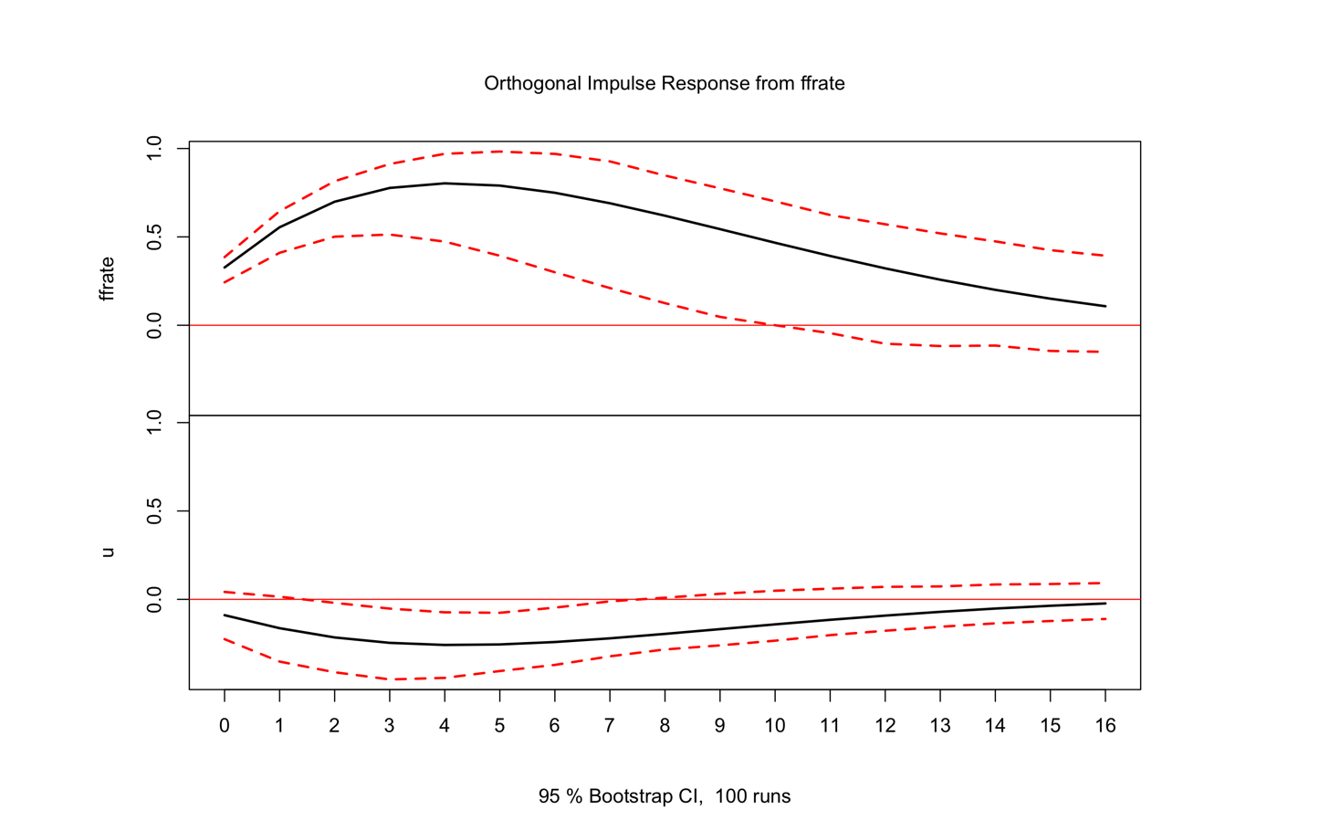 Figure 1 shows the impulse response functions (IRF) of the residuals from the Federal Funds Rate (FFR). The top and bottom half of the graph represent the IRFs $\frac{d{FFR}_{t}}{dε_{t-j}^{FFR}}$ and $\frac{dU_{t}}{dε_{t-j}^{FFR}}$ respectively, which calculate the change in the dependent variable (FFRt, Ut) when there is a small change in the Federal Funds Rate shock ($ε_{t-j}^{FFR}$) and the red-dotted lines are the 95% confidence interval. When there is an overlap between the confidence interval and the zero line, the estimates of the IRF are not statistically different from 0 (i.e. causal effect is zero). According to figure 1, the estimate for the $\frac{dU_{t}}{dε_{t-j}^{FFR}}$ function was always negative at all lags so the potential causal effect was negative. However, only during the lag 2 to 7 period, the coefficient is statistically different from zero, so we conclude that from lag 0 to lag 1, the causal effect was zero, but as we the value of j increased to two lags, the negative causal effect starts to occur, and it continues to stay negative until lag 7 before returning back to zero. Therefore, we can conclude a positive shock to FFR during two to seven lags ago has a statistically significant negative causal effect on current unemployment rate. The effect is typically measured at around a -0.1 to -0.3 change to current unemployment rate. But if the shocks occur too recent (within one lag) or long ago (more than eight lags), they have negligible causal effect.

Figure 1

$$\frac{d{FFR}_{t}}{dε_{t-j}^{FFR}}$$

$$\frac{dU_{t}}{dε_{t-j}^{FFR}}$$

In addition to the unemployment rate, we also computed the impulse response with the growth rate of real GDP as the dependent variable and the analysis was pretty much analogous with the previous one. According to figure 2, the estimated impulse response function $\frac{dY_{t}}{dε_{t-j}^{FFR}}$ had a value greater than zero, at all lags, indicating that the Federal Funds Rate (FFR) has a positive causal effect in the growth rate of real GDP. However, similar to the figure 1 during lag 2 to lag 7, the 95% confidence interval didn’t overlap with the zero line, which indicated the causal effect is statistically different from zero only within this period. Hence, we concluded that the FFR indeed possessed a positive causal effect on the change in GDP growth rate, but this effect was also limited to the timeframe being within two to seven lags of the shock.

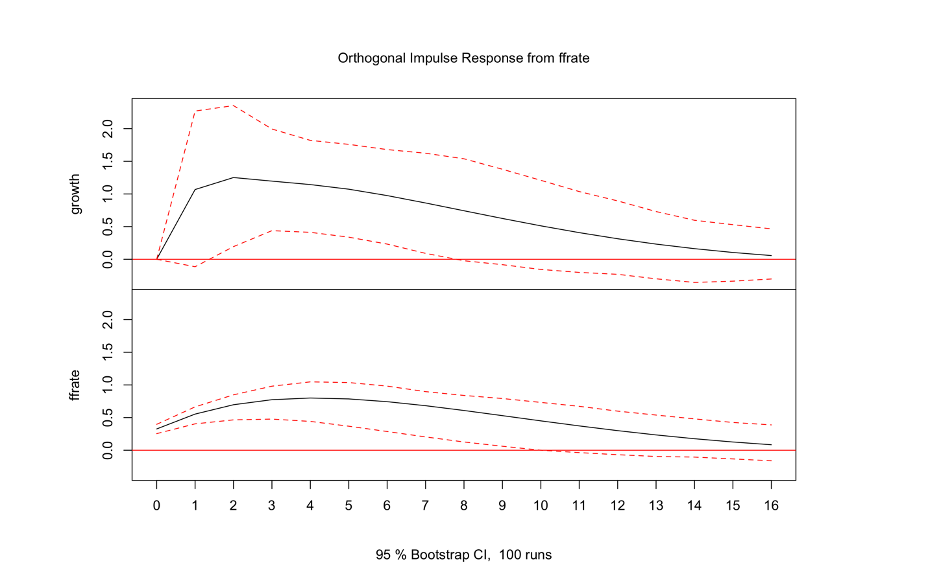

Figure 2

$$\frac{dY_{t}}{dε_{t-j}^{FFR}}$$

$$\frac{d{FFR}_{t}}{dε_{t-j}^{FFR}}$$

In conclusion, we deduced from the two impulse response functions (IRF) that Federal Funds rate has a negative causal effect on unemployment rate, and a positive causal effect on GDP growth rate, these findings largely support economists’ claims when they proposed the ADAS model and Philip’s curve. However, both causal effects did not happen contemporaneously. Both IRFs indicate that the shock in Federal Funds Rate has to occur within two to seven lags in order for the effect to be statistically significant, while shocks occurring too recent (=< 1 lag) or too long ago (>=8 lags) would not have a causal effect on both the unemployment rate and real GDP growth rate.

**Discussions of Limitations, Robustness, and Extensions**

Although these findings could prompt further investigation in the causality of monetary policy to other economic performance indications, they are not conclusive that there was absolutely a causal relationship between the Federal funds rate (FFR), GDP growth rate, and unemployment rate due to some omitted variable bias. In our analysis, we did not take into consideration the fact that the FFR and Unemployment rate data are non-stationary which could potentially lead to problems such as spurious regression. Spurious regression usually occurs when performing regressions on two non-stationary time-series data, the results would show that two variables were highly correlated, but in reality, there could be no relationship between the variables, and this would be caused by the non-stationary trend within both trends. Therefore, the causal effect we have concluded could potentially be the outcome of spurious regression. Moreover, in terms of external validity this project solely focuses on economic data within Wyoming state, it is uncertain whether the same conclusion we obtained from studying Wyoming’s data can apply to the entire United States. Since each state’s GDP and labor force contribute to different economic sectors, some are more sensitive to FFR while some are not, as a result, the economic composure varies between different states. Hence, we might be getting entirely opposite conclusions by using data from other states. Therefore, it is necessary to take these concerns into consideration when doing related studies so that a more consistent and unbiased estimate can be obtained.

**APPENDIX I**

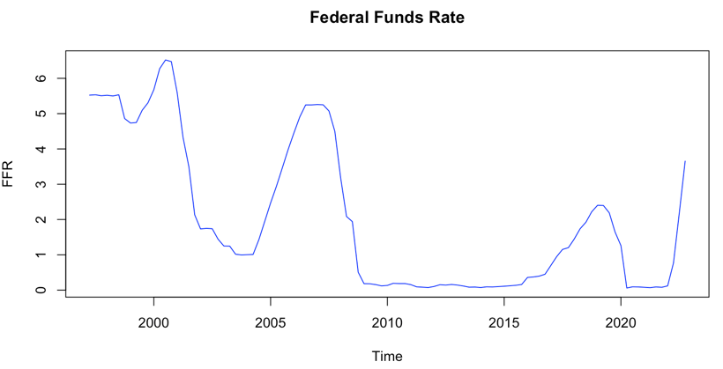**Relevant graphs of the dataset, including autocorrelation functions and partial autocorrelation functions and other impulse response functions:**

